MCj04136180000[1] L king at Literacy

*Kannapolis Middle School Special Edition - March 2009*

**Four Elements of Successful EOG Testing**

I think the best ways to prepare students for the EOG tests are to:

* Continue to do a good job teaching.
* Continue to integrate the reading strategies AND tools into instruction and continue to allow time for reading.
* Continue (or start now!) to teach students how to identify the types of questions they can be asked (more on that below).
* Constantly expose students to content and testing vocabulary.

I think the combination of the above factors can do much more than any isolated 6-week period of intense “practicing.” However, I realize that the state tests are a unique “beast” and there are certain things that should be addressed with students. I suggest **four elements** that, if addressed and expected, can prepare students better than six weeks of “practicing.” We should, in fact, have students practicing these behaviors **throughout the year**, because they are not unique to a state test. These are elements of good teaching and of successful students. At times, I may mention things specific to the Reading Comprehension EOG, but they are meant to apply to **all tests**. The four elements are:

*ELEMENT 2*

**PROCEDURES**

Most students have taken these tests enough to know how to take them… or do they? Have they been shown the most effective procedures or left to come up with their own method of working through the test? Can you just give them advice and hope they apply it? My **suggested plan of attack** follows. It should be taught, modeled, and practiced. Procedures are routines and must be rehearsed until they become automatic. Again, these are not unique to testing; they are good teaching practices for the entire year.

1. **Actively read** to understand as much as possible by using reading tools (preview, self-monitor, reread, slow down, mark the text).

*THEN…attend to the questions*

1. **Read and understand the question**. Must use reading tools here, too! Restate (summarize) the question.
2. Decide what is required to answer the question (**type of question**):
   1. Locate specific information in the text?
   2. Search the text for clues and connect ?
   3. Access prior knowledge and think critically?
3. **Attempt to answer the question first**, before looking at answer choices.
4. **Find the answer choice** that best fits your answer and eliminate others.

*ELEMENT 1*

**THE APPROACH**

* **Goal**: To actively read and comprehend the selections as much as possible by using reading tools in order to best answer the questions that follow.
* “**Wrestle With the Text**” mentality – squeeze as much meaning as you can out of it (selections, word problems, questions)
* Using the reading tools (previewing text, self-monitoring, rereading, slowing down, marking the text) must be the **consistent expectation** throughout the year. This is not test prep – this is active reading!
* If students see use of the reading tools as punishment or a burden, then they don’t understand the purpose. Give them flexibility and choices, but mostly, help them understand that the purpose of active reading is to improve comprehension. **Prove to them that it works!** Give them a selection and tell them to read straight through using no tools (no notes, no rereading). Then “quiz” them. Then, give them another one (or use the same one, even) and allow students to reread, mark the text, adjust their rate, etc. Make them see that when they use the tools, they are better at summarizing, inferring, visualizing, etc. They comprehend better, and more answers will come more easily when they are faced with questions. Especially higher-level questions.

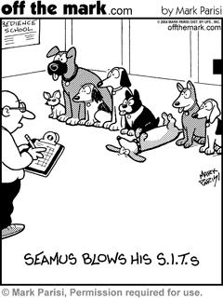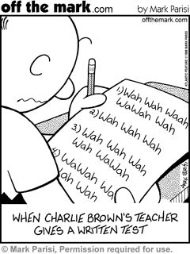

*ELEMENT 3*

**EFFORT**

* Many students don’t believe that effort can pay off, especially with these tests.
* Remind students of external incentives for effort:
  + Exam exemptions
  + Grade promotion
  + Days off from school
  + No retakes or more remediation
  + Participation in celebrations
* Show students in small ways now that effort can pay off.
* Consider showing this 212o video: <http://www.212movie.com/>
* Approach the tests as opportunities to demonstrate learned skills, not as something to dread/fear.

*ELEMENT 4*

**STAMINA**

* On the Reading Comprehension EOG, there are 9 selections with 6-9 questions for each selection. Each reading selection can be anywhere between 1 and 3 pages. This is undoubtedly **a LOT of reading**. The test is virtually untimed, so students could literally be reading straight for hours and hours. This obviously requires stamina. How can we help?
* “Face time” with text – **independent (but active!) reading** during 4th period, regular classes, and at home
* **Self-Regulation** – students must be aware of their attention and “state” and have a handful of ways to redirect themselves.
  + Active reading will help
  + Change positions
  + Consider reading the longest selections first
  + Set goals and reward self with a short break