Looking at Literacy

*Kannapolis Middle School June 2008*



***From the “Desk”  
  
of Mrs. Wolford***

Thank you all for completing the online Literacy Coach Survey at the end of last month. I’ve compiled the results and was pleased to see that you are finding the Literacy Coach position to be beneficial to you. I received several suggestions for improvement, which are very helpful as I begin planning for next year!



Focus On:   
 Defining Literacy

Literacy is often over-simplified and defined as the “ability to read and write.” In fact, my desk copy of the Oxford Essential Dictionary uses that exact definition. I, too, once defined literacy that way. However, I hope we all can agree that literacy is more than that. My current definition of literacy (as well as many experts’ definitions, such as Dr. Arthur Costa and Rosemary Taylor) begins with the ability to read and write, but also includes speaking, listening, viewing, and thinking in order to make meaning of something.

Determining literacy is also more complex than just saying, “You either got it, or you don’t!” It should be seen as a continuum on which one can always progress. As Dr. Costa writes, “One is never fully ‘literate’; rather a literate person engages in continuous learning about a subject to become even more ‘literate.’” (Costa, Arthur L., Ed.D. "The Attributes of Literacy." Habits of Mind: Writing Across the Curriculum Conference, NC State University, 26 April 2008.)

***Lesson Planning for Student Learning***

**Some Things to Consider**

**Activating –** How will I help students activate their prior knowledge, and for those with no prior

knowledge, how can I help them build it? How do I make this information relevant?

**Organizing –** How will I help students “chunk” the information?

**Comprehending –** After engaging in the lesson, what will students do to transform the

information into something meaningful to them? How can we take the

learning to a deeper level?

**Summarizing –** How will I give students an opportunity to review and summarize?

**Collaboration –** How will students get the opportunity to work together and learn from each other?

**Technology –** How can I incorporate technology to enhance student learning?

**Assessment –** How will I assess student learning throughout the lesson and adjust instruction

as needed?

**Differentiation** –How can I differentiate the content, process, or product to meet student needs?

**Coaching –** How can the Literacy, Media, and/or Technology Coach support me?

**Integration** – How can I integrate other subject areas to help students make connections?

If you think about literacy in this way – as a process that includes reading, writing, thinking, speaking, listening, and viewing in order to make meaning in a variety of subject areas – then it becomes obvious that every teacher teaches literacy. Every teacher teaches students to read, write, think, listen, speak, and view *about their subject* and any other integrated subjects. The goal is to make students more literate in that subject area.

Perhaps sharing this way of thinking about literacy will help you think about ways I can help you as Literacy Coach. It *can* be as basic as helping you create a writing assignment to fulfill a requirement you have. However, it can be much more than that. I am here to help you find the most effective ways to develop your students’ literacy in your subject area. I look forward to continuing our work together next year in whatever way you see fit.

Classroom Reading Research



Thanks to all of you for helping us collect data on the amount, types, and methods of reading our students are doing during the school day. Special thanks to the committee members that volunteered their time to coordinate the project: Mrs. Wright, Ms. Fitzpatrick, Mr. McDermott, Mrs. Smith, Mrs. Johnson, and Mrs. R. Parker.

The data is organized and was shared at the last CIT meeting. I hope your CIT representative shared the data with you, but here is a short summary of the data and the responses that CIT members produced after analyzing the data. (See tables to right.) All charts are also saved on the network at: G:\Files\Protected Files\Literacy.

Data Analysis: Some Positive Responses

*Students are reading over 60 minutes a day. ☺*

*The balance of genres reflects the balance of genres on the Reading EOG. ☺*

*Students seem to be reading in different ways in many classes. ☺*

Data Analysis: Some Questions to Consider

(See the full report of questions produced by the CIT team at G;\Files\ProtectedFiles\Literacy)

*What are ways to allow the students to select text?*

*Are we differentiating texts to meet student needs?*

*Since teachers are using independent reading so much, are we teaching strategies for students to use to ensure they are comprehending?*

*What can we do to motivate students with all this independent reading of text?*

*Are we being explicit about how to read different types of text?*

*What are some alternatives to whole-class reading, because that’s usually “round robin,” a strategy that is not supported by research?*

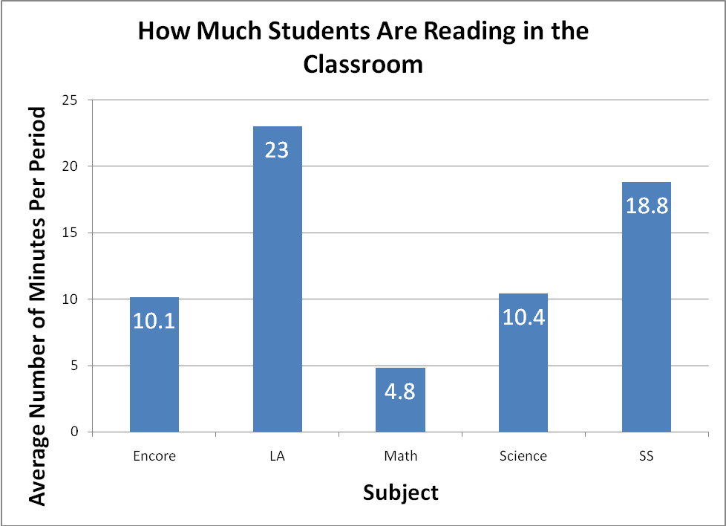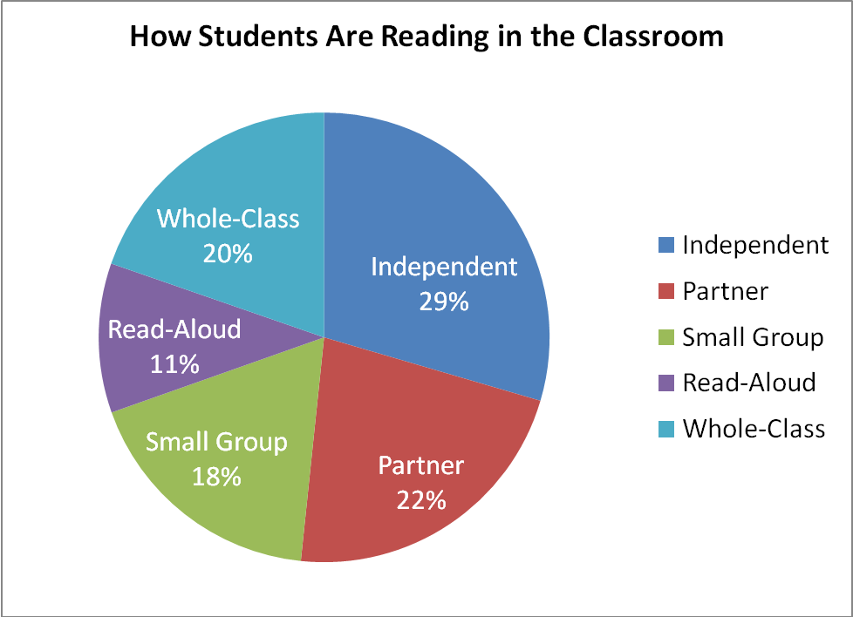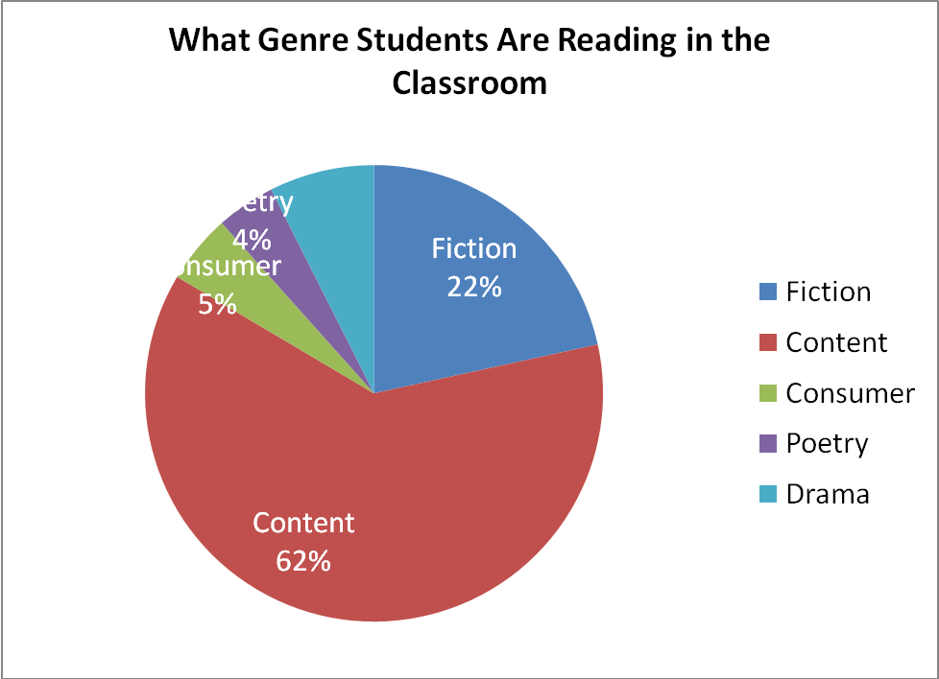

As we embark on our collaborative journey as an IMPACT school next year, I propose that we continue the positive practices that the data shows as well as attempt to answer some of the questions that CIT team raised. My roles in this effort will be to find opportunities to discuss, plan, and reflect and then facilitate the sharing of ideas among the staff. Congratulations on your participation in a project that will help us make data-informed decisions!

## BACK AT YA!

In last month’s newsletter, I posed a question to you and asked for your feedback:

***Reflect on the literacy learning in this classroom: On the board is written, “Read pp. 59 – 66, do the defs, answer questions   
1-9.” Students begin working.***



Thanks to Mrs. Nelson and Mrs. Elvington for taking the time to share their thoughtful responses with all of you. They definitely earned their treat bag!

***Mrs. Nelson:*** *I don't believe that there is a lot of literacy learning going on in this classroom (but I will admit I have done a similar thing in my own class). The students are expected to read new material, copy definitions and learn and I just don't see this happening. First, if the reading selection is at or above grade level, it will have parts that some students do not understand. Therefore, it is possible there are some students who will not comprehend the selection at all. As for the vocabulary, by simply looking up definitions without prior experience with these terms will be difficult to make connections and really understand the passage and vocabulary. So, although I think the teacher probably thinks he/she is doing the children a favor, in actuality, the students are not learning much at all.*

***Mrs. Elvington:*** *For an independent, self-starter, an assignment of this nature, while boring and relatively meaningless, would enable him/her to acquire a certain amount of knowledge. However, the average student with limited interest and low attention span, an assignment of this nature would result in sleep, disruptions, or apathy. If we assume, and it is a rather large assumption, that the teacher has set a purpose for the activity, then there may be a few more students who will be able to successfully complete the activity. The majority will still be bored out of their minds and will actively seek out ways to divert their attention and satisfy their need for entertainment or engagement.*

*If we move beyond the fact that the lesson is devoid of creativity and engagement, we must begin to look at the child development theory and learning theory. The teacher has not "set the stage." As educators we must acknowledge that for a child to truly learn new material, they must be able to connect that information to existing knowledge. When we acknowledge this fact, then we understand the importance of activating strategies. Once the stage is set, the teacher must guide the students through the reading, always being careful to relate back to existing knowledge. At this phase of learning, graphic organizers, reading guides, modeling, and note-taking strategies become an integral part of the learning experience.*

*Now, I should mention that so far the majority of activities that have been discussed would appeal to only about 1/3 of our students. If we consider multiple intelligences and learning styles, we have appealed to Logical/Mathematical Intelligence and Intrapersonal Intelligence. Depending on the design of the lesson one might also appeal to Visual/Spatial or Interpersonal. While straight out question and answer is necessary, it must be reinforced with a variety of modes in order to enhance the instruction and retention of learning by a wider range of students.*

*The one aspect of learning, that I believe often goes undiscussed or lightly brushed over, is closure. In my opinion, closure is as important as an activating strategy. (While I believe this wholeheartedly, it is most likely my greatest weakness because I become so involved in the lesson that I lose track of time.) Closure is the opportunity to reconnect the newly acquired information with past knowledge, connect with real-life experiences, and assess student learning. Closure lays the foundation for the next day's learning in a way that is meaningful.*

*If I am truthful, I am guilty of writing an assignment on the board with very little direction. If we are all truthful, there are times when we are sick or don't feel good that we give students an assignment that may not be the most engaging. Yet, there are two factors that I believe should be kept in mind. One, we must acknowledge to ourselves and others that this is NOT the best educational practice because we have the knowledge and experience that dictates otherwise. Two, even on those days when we are not up to the challenge of being "on the stage" we are still held accountable to the learning that does or does not take place within our classroom. Our students deserve our "A" game.*